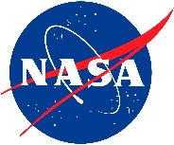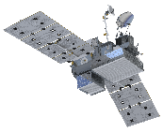http://pmm.nasa.gov/sites/all/themes/waterfalls/images/gpm-logo-1.png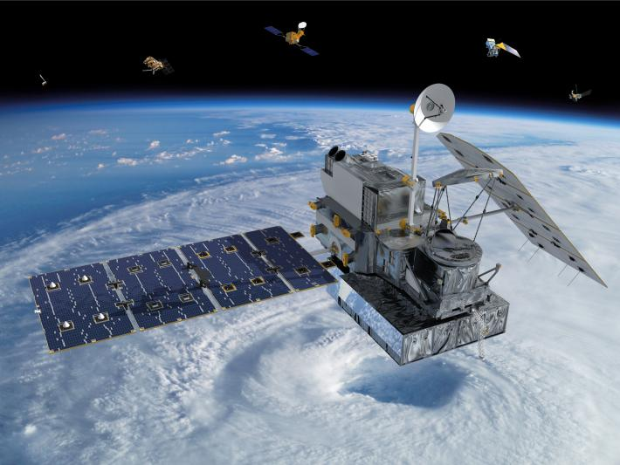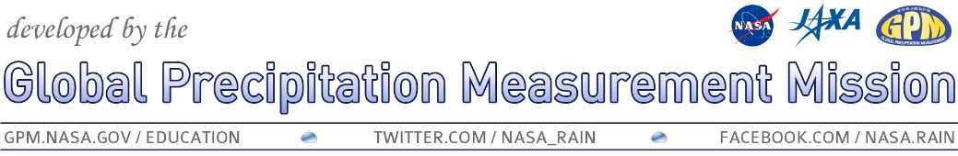

**SAMPLE – change to fit your event!**

### AnyTown Middle School

Science Department

www.publicschooldistrict. org/anytownms

gpm.nasa.gov/education/

[Your date], 2014

6:30 to 8:00 pm

Anytown Middle School

GPM Rain EnGAUGE Event!

Celebrate the launch of NASA’s Global Precipitation Measurement mission and learn about the science behind measuring precipitation from space, as well as what it means for us on the ground. There will be hands-on activities, door prizes, and even the chance to make your own edible satellite!

## Virtual guest speaker from NASA!

## Learn how GPM can see inside storms!

## Hands-on and interactive activities!

## Make an edible model of the satellite!

## Explore STEM careers that might interest you!